Counterfeit Currency Detection

with

Machine Learning & Computer Vision

Major Group Project

By

Meghna, Kim, Dylan & Shaheer.

I. **Abstract**

This study addresses the critical global and regional challenge posed by counterfeit currency through the development of an advanced, dual-model detection system employing deep learning technologies. A Convolutional Neural Network (CNN) model was developed and trained, achieving a notable 91% accuracy in classifying currency authenticity. Concurrently, a YOLOv8 model was deployed to accurately identify the denominations of Pakistani banknotes. Both models were hosted on Google Drive, enabling efficient and seamless updates. These models were integrated within a real-time detection framework powered by Raspberry Pi 5 hardware, utilizing Natural Language Processing (NLP) to audibly announce the detection results. A significant and unexpected outcome was the CNN model’s perfect generalization to accurately detect the authenticity of 5000 rupee notes without prior training on this denomination.

II. **Introduction**

Counterfeit currency remains a pervasive economic threat, adversely impacting economies and businesses globally, particularly in regions with limited resources for sophisticated detection systems. This research introduces an innovative, cost-effective, and practical solution specifically designed for detecting counterfeit Pakistani currency. Employing a dual-model deep learning approach utilizing CNN for authenticity verification and YOLOv8 for denomination recognition, the solution was deployed on affordable Raspberry Pi hardware, ensuring accessibility and ease of use. This project aimed to enhance economic security through accurate, real-time currency authentication.

III. **Research Question and Purpose**

A notable gap identified in current literature and practice is the scarcity of affordable, reliable, real-time counterfeit currency detection systems suitable for small-scale businesses and enterprises. The research questions guiding this study were: (1) Can CNN models effectively discern counterfeit currency under practical, real-world conditions? (2) Is it feasible to perform real-time currency verification and denomination identification using minimal-cost computing solutions such as the Raspberry Pi? The purpose of this study was to develop robust CNN and YOLOv8 models to authenticate and identify currency denominations accurately, thereby implementing a practical hybrid detection system capable of seamless updates from cloud-hosted resources.

IV. **Literature Review**

Previous research has primarily utilized either traditional image processing methods or computationally intensive machine learning models unsuitable for real-time deployment in resource-constrained environments. This study reviewed relevant literature extensively, including CNN architectures for image classification, YOLO-based object detection methodologies, and image preprocessing techniques such as greyscale conversion and contour-based cropping. It underscored multidisciplinary insights spanning computer vision, machine learning, IoT deployment challenges, and security considerations, clearly identifying the existing knowledge gap regarding real-time, low-cost detection solutions.

The literature indicated substantial efficacy of CNN and YOLO models in similar tasks, forming the theoretical and methodological basis for the current research. This foundation justified the chosen methodologies and guided dataset preparation and model architecture decisions.

V. **Methodology**

The datasets were custom-created, with authentic and counterfeit notes meticulously captured and augmented through rotations, brightness, contrast adjustments, and contour-based cropping. Counterfeit notes were exceptionally similar to genuine notes, exhibiting only minor distinctions in texture, image sharpness, and colour density. To ascertain the CNN's ability to detect these subtle differences, initial exploratory tests evaluating colour density and sharpness differentiation were conducted.

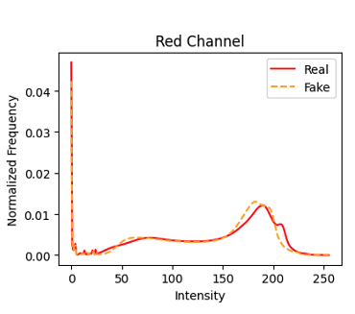

Figure 1 – Histogram for colour differences.

Data splitting followed a robust 70/20/10 strategy for training, validation, and testing.

This research adopted an experimental, quantitative design, employing two distinct datasets. The first dataset consisted of coloured images of 100, 500, and 1000 rupee notes utilized to train a CNN for authentication purposes, achieving 91% accuracy.

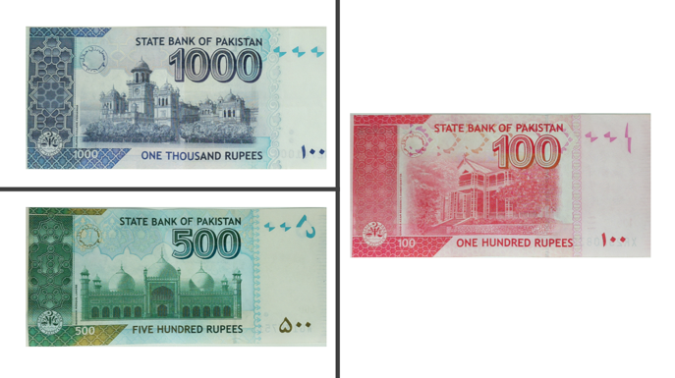

Figure 2 – Pakistani Currency Bills

The second dataset encompassed greyscale images of 100, 500, 1000, and 5000 rupee notes, specifically for YOLOv8 denomination detection training. Image preprocessing methods included contour-based cropping, resizing, augmentation, and greyscale conversion to optimize model performance and reduce computational load.

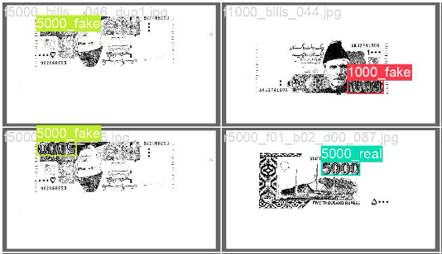

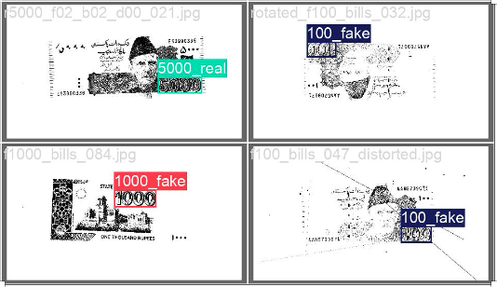

Figure 3 – Grey scaled images.

The research methods ensured rigorous validation through appropriate dataset splits and metric analyses, including accuracy, precision, recall, F1-score, and confusion matrices, thus ensuring reliability and validity of outcomes.

Figure 4 – Results CNN.

VI. **Planning, Analysis & Organization**

Clear timelines guided the entire project, detailing dataset preparation, model training, validation phases, and Raspberry Pi integration. The analytical framework encompassed detailed metric assessments and threshold calibration, ensuring logical progression from initial dataset creation to final hybrid model deployment. This structured approach effectively addressed the identified knowledge gaps, demonstrating CNN and YOLOv8 models' efficacy in real-time, cost-effective counterfeit detection. Notably, the unexpected high accuracy of the CNN model on untrained 5000 rupee notes highlighted its remarkable generalization capability. The conclusion emphasizes significant achievements and the project's broader impact on currency authentication and economic security.

VII. **Other Considerations**

Ethical practices were strictly adhered to throughout the project, ensuring privacy and data protection during image collection and processing. Ethical considerations regarding the implications of deploying counterfeit detection technologies were thoroughly assessed. Additionally, comprehensive Occupational Health and Safety (OHS) measures were implemented, covering safe hardware installation, electronic component handling, and precautions against potential electrical hazards and malfunctions.

VIII. **References**

Alghazo, J. and Bashir, A., 2020. [A Survey of Deep Learning Techniques for Image Classification. IEEE Access, 8, pp.](https://ieeexplore.ieee.org/document/9039893) 43177-43191.

Redmon, J. and Farhadi, A., 2018. [YOLOv3: An Incremental Improvement.](https://arxiv.org/abs/1804.02767) arXiv preprint arXiv:1804.02767.

Bhunia, A.K., Roy, P.P., and Kim, T.-H., 2020. [Counterfeit Currency Detection using Deep Learning Techniques. Applied Soft Computing,](https://www.sciencedirect.com/science/article/abs/pii/S0893608025003089) 93, p.106399.

Krizhevsky, A., Sutskever, I. and Hinton, G.E., 2012. [ImageNet Classification with Deep Convolutional Neural Networks. Advances in Neural Information Processing Systems,](https://papers.nips.cc/paper_files/paper/2012/hash/c399862d3b9d6b76c8436e924a68c45b-Abstract.html) 25, pp.1097-1105.

Wang, C.-Y., Bochkovskiy, A. and Liao, H.-Y.M., 2022. [YOLOv7: Trainable Bag-of-Freebies Sets New State-of-the-Art for Real-Time Object Detectors.](https://arxiv.org/abs/2207.02696) arXiv preprint arXiv:2207.02696.